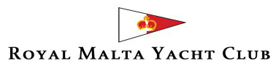

RMYC / Lions Club August Cruise 2018

Thursday 9th August 2018 – 7.00pm
BBQ Menu - Euro 25.00 per person – RMYC Roof

Welcome drink – prosecco

Potato Salad
Jewelled Couscous
Chicken Skewers
Pork Loin in whole Grain Mustard
Sword Fish
Fruit Salad

Half a bottle of wine per person
Coffee

Saturday 18th August 2018 – 8.00pm
Pasta Menu - Euro 20.00 per person – RMYC Roof

Spinach ricotta macaroni baked
Garganelli beef and mushroom
Penne norma
Ice cream

Half a bottle of wine per person
Coffee

